HANDS-ON LAB GUIDE
Azure Databricks End to End Workspace and Delta Lab
Lesson 2 | Azure setup through governed Delta table for 14 learners
TRAINER PREP  60-90 minutes | LEARNER LAB  120 minutes | LEVEL  Beginner | EVIDENCE  Workspace + Delta table

Lab outcome
The trainer deploys one Azure Databricks workspace, onboards 14 learners with least privilege, prepares governed compute and Unity Catalog objects, and then guides every learner from notebook creation through a verified Delta table.

Recent UI note
VERIFIED DOCUMENTATION: The interface sequence and screenshots were checked against Microsoft Learn pages updated through September 2026. Databricks rolls out UI changes gradually, so an icon or label can differ slightly by workspace type, region, entitlement or preview status.

Trainer setup before class
- One Azure Databricks Premium workspace with Unity Catalog enabled.
- The 14 learners are assigned through one Microsoft Entra group.
- Serverless interactive compute is available, or an approved shared compute resource grants CAN ATTACH TO.
- The catalog training_lab exists, with student_01 through student_14 schemas or permission for each learner to create the assigned schema.
- A fallback notebook and synthetic dataset are available if compute or catalog permissions are delayed.

Part A - Create the Azure Databricks workspace

1. Confirm the prerequisites
Requirement | Trainer check | Why it matters
Azure subscription | Use an eligible paid or enterprise subscription, not an Azure Free Trial subscription. | Current workspace deployment guidance excludes Azure Free Trial subscriptions.
Azure role | Trainer or platform administrator has Contributor or Owner at subscription scope, or the documented custom permissions. | Workspace creation deploys Azure resources and may register resource providers.
Region | Choose one supported by the organization and the required Databricks features. | Serverless availability, quotas and data residency vary by region.
Naming | Reserve a unique workspace name and one dedicated resource group. | Clear names simplify support, cost tracking and cleanup.
Identity | All 14 learner accounts exist in the same Microsoft Entra tenant. | Workspace users must belong to the workspace tenant.

COST CHECKPOINT: Creating the workspace itself is only the beginning. Charges can come from Databricks usage units and underlying Azure resources. Confirm the subscription owner, budget and cleanup date before deployment.

2. Choose the workspace type
Workspace type | Use for this training when | Important note
Serverless | The region supports it and the organization allows the current preview. You want the simplest notebook and SQL experience. | Comes preconfigured with serverless compute and default storage.
Hybrid | Preview use is restricted, classic networking is required, or you need Scala, R, legacy Spark or private connectivity. | Creates a classic workspace; serverless compute may still be available.

RECOMMENDED CLASSROOM CHOICE: Use Serverless for the shortest setup when the client permits the preview and the selected region supports it. Otherwise use Premium Hybrid and enable serverless notebook compute when available. Do not add custom networking unless it is part of the learning objective.

3. Create the resource group
- Sign in to https://portal.azure.com with the trainer or platform-administrator account.
- Search for Resource groups and select Create.
- Select the approved subscription.
- Enter rg-dbx-training and select the approved region.
- Select Review + create, then Create.
Trainer explanation: the resource group is the Azure lifecycle and cost-management container. It is not the Databricks catalog, schema or workspace folder.

4. Deploy Azure Databricks from the portal
- In the Azure portal, select Create a resource.
- Select Analytics, then Azure Databricks.
- Complete the Basics page using the field guide below.
- Open Encryption only if the client requires customer-managed keys.
- Select Review + Create, resolve validation errors, and then select Create.
- Watch Notifications until the deployment status becomes Running or Succeeded.
Portal field | Classroom value | Explanation
Workspace name | dbw-cdg-training-<unique> | Use letters, numbers and hyphens; add a short unique suffix if needed.
Subscription | <approved subscription> | The subscription that owns billing and Azure resources.
Resource group | rg-dbx-training | Keeps the dedicated lab resources together.
Location | <approved supported region> | Use one region consistently unless the client requires otherwise.
Pricing tier | Premium | Required for the governance and access-control features used in this lab.
Workspace type | Serverless or Hybrid | Choose using the decision table on the previous page.

DEPLOYMENT FAILURE: A failed workspace can remain in Azure in a Failed state. Read the deployment error, correct quota, policy, provider or naming problems, and remove only the dedicated failed workspace before retrying.

5. Launch and record the workspace
- Open the deployed Azure Databricks resource.
- On Overview, confirm the provisioning status is Running.
- Select Launch Workspace.
- Bookmark the unique URL in the form adb-<workspace-id>.<number>.azuredatabricks.net.
- Open the profile menu and confirm the trainer identity and workspace name.
SECURITY RULE: Use the unique per-workspace URL. Do not give all learners Azure Contributor or Owner access just so they can launch Databricks. Add them as Databricks workspace users instead.

Part B - Onboard the 14 learners

6. Prepare the learner identities
- In Microsoft Entra ID, confirm student01 through student14 exist in the workspace tenant.
- Create the security group dbx-training-students.
- Add all 14 learner accounts to the group.
- Keep the trainer or platform-administrator account separate from the learner group.
For a small temporary batch, learners can be added individually. A group is preferred because workspace, compute and catalog permissions can be assigned once and audited consistently.

7. Add learners to the Databricks workspace
- In the Databricks workspace, select the profile name in the top bar and choose Settings.
- Open Identity and access.
- Next to Users or Groups, select Manage.
- Select Add user or Add group. Select an existing identity, or use Add new when appropriate.
- Enable Workspace access. Enable Databricks SQL access only when the class needs SQL warehouses.
- Leave Admin access off for learners and save the assignment.
CURRENT IDENTITY BEHAVIOR: Automatic identity management is enabled by default for accounts created after 1 August 2025. A newly added identity can take a short time to appear in search, even though it is already present in the full list.

8. Apply the least-privilege learner model
Capability | Trainer | Learner group
Workspace administration | Yes | No
Workspace access | Yes | Yes
Create unrestricted compute | Only if required | No
Attach to approved shared compute | Yes | CAN ATTACH TO
Use training catalog | Yes | USE CATALOG
Create objects in own schema | Yes | Only in assigned schema

Part C - Prepare compute and Unity Catalog

9. Choose the compute path
Path | Trainer action | Learner experience
Serverless notebook compute | Confirm serverless is enabled and available in the workspace. | Select Serverless in the notebook compute selector, or run the first cell if it is automatically selected.
Shared classic compute fallback | Create one small policy-controlled resource and grant the learner group CAN ATTACH TO. | Select the trainer-created resource; learners do not edit or resize it.

10. Create classic compute only when required
- In the Databricks sidebar, select Compute.
- Select Create compute.
- Enter shared-training-compute and select the trainer-approved policy.
- Select the current Long Term Support runtime supported by the course.
- Use Standard access mode, the smallest permitted worker type, and autoscaling from 1 to 2 workers.
- Set auto termination to 15 minutes and create the compute resource.
- Open Permissions and grant dbx-training-students CAN ATTACH TO.
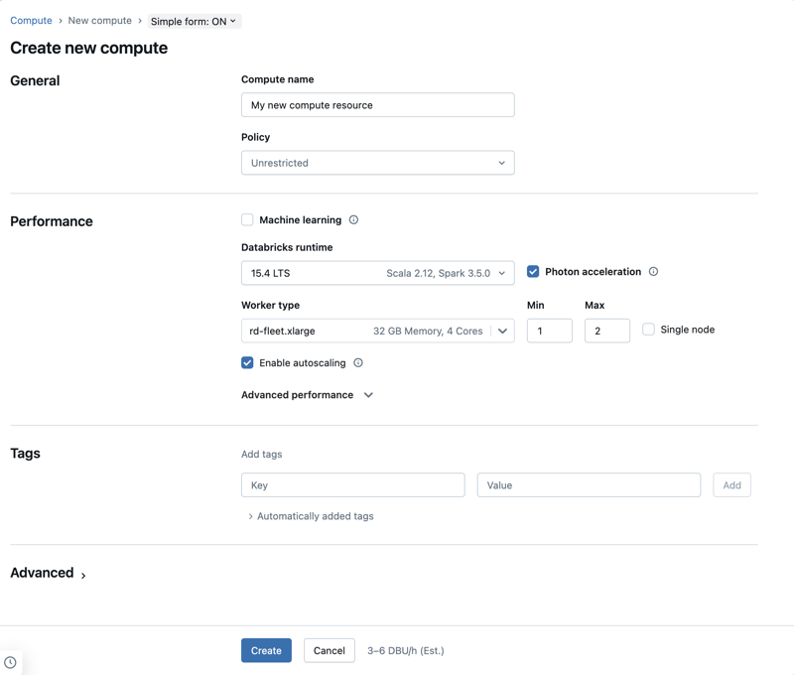
Figure 1. Current simple form for creating classic all-purpose compute.
Source: Microsoft Learn - Azure Databricks documentation
The runtime and VM shown in the screenshot are examples. Use the current LTS runtime and the smallest instance allowed by the client policy and regional quota.

11. Create the training catalog
Run the following as a metastore administrator or a principal with CREATE CATALOG. If the client already provides a governed catalog, use that catalog and do not create a parallel one.
SQL
%sql
CREATE CATALOG IF NOT EXISTS training_lab;
GRANT USE CATALOG ON CATALOG training_lab TO `dbx-training-students`;

12. Create one isolated schema per learner
Replace the example tenant domain before running this administrator cell. The group receives catalog visibility; each learner receives create privileges only in the assigned schema.
PYTHON
tenant_domain = "yourtenant.onmicrosoft.com"
for number in range(1, 15):
learner = f"student{number:02d}@{tenant_domain}"
schema = f"student_{number:02d}"
spark.sql(f"CREATE SCHEMA IF NOT EXISTS training_lab.{schema}")
spark.sql(
f"GRANT USE SCHEMA, CREATE TABLE, CREATE VOLUME "
f"ON SCHEMA training_lab.{schema} TO `{learner}`"
)
ALTERNATIVE: If individual grants are not permitted, make a trainer-created schema available to each learner through the organization's approved group and ownership model. Never solve one permission issue by making every learner a workspace administrator.

13. Validate the setup from a learner account
- Sign out of the trainer session or use a separate private browser window.
- Sign in as one assigned learner.
- Confirm the learner can open the workspace but cannot access administrator settings.
- Create a temporary notebook, select approved compute and run SELECT current_user(), current_catalog(), current_schema().
- Confirm the learner can create a table only in the assigned student schema.

Part D - Trainer preflight

1. Verify the environment
Check | Pass condition | If it fails
Identity | Learner signs in with the assigned organizational account. | Check tenant and Entra group membership.
Workspace | Workspace opens and left navigation is visible. | Verify workspace assignment; do not make the learner admin.
Compute | Serverless or approved compute appears in the notebook selector. | Check region/support, compute ACL or policy.
Catalog | training_lab is visible and assigned schema is usable. | Validate USE CATALOG and schema ownership/grants.
Browser | No corporate proxy or extension blocks the UI. | Test from the learner network before class.

2. Launch the workspace
- Sign in to portal.azure.com using the assigned organizational identity.
- Open the trainer-provided resource group and select the Azure Databricks workspace.
- On the workspace Overview page, select Launch Workspace.
- Confirm the workspace name and the learner identity in the top-right profile menu.
TRAINER CHECKPOINT: If a learner has Azure portal access but Databricks denies access, Azure RBAC and Databricks workspace assignment are separate checks. Resolve the workspace assignment instead of granting broad Azure ownership.

3. Orient learners to the navigation
UI area | What learners use it for
+ New | Create notebooks, queries, dashboards and jobs.
Workspace | Browse personal and shared workspace objects.
Catalog | Browse governed catalogs, schemas, tables and volumes.
Workflows / Jobs & Pipelines | Create repeatable notebook tasks and data pipelines.
Compute | View approved serverless and classic compute resources.
SQL Editor | Run analytical SQL using a SQL warehouse.

Part E - Create the learner notebook

Step 1 - Open the notebook creation menu
- Select + New in the left sidebar.
- Select Notebook.
- Wait for the blank notebook to open. New notebooks initially use the Drafts area until they are named.
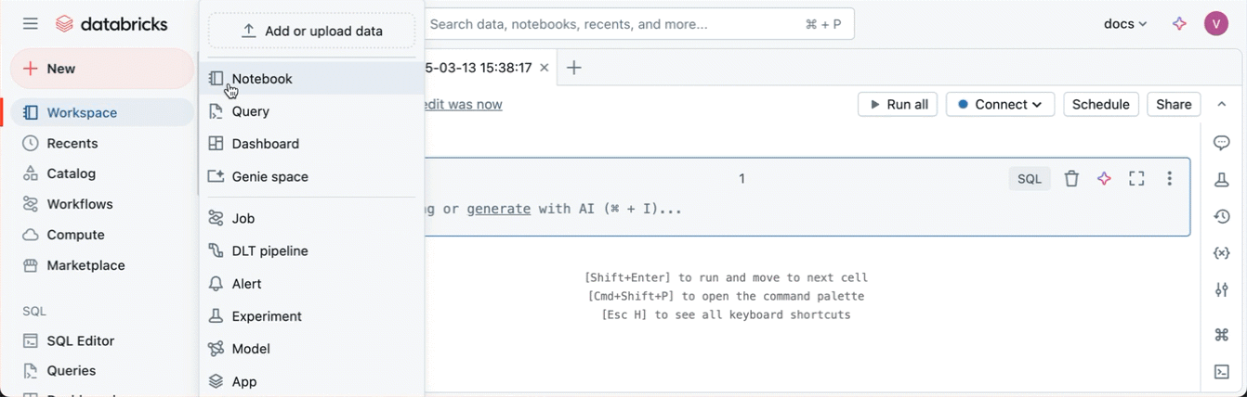
Figure 2. Use + New > Notebook in the workspace sidebar.
Source: Microsoft Learn - Azure Databricks documentation
TERMINOLOGY CAUTION: The official animation can show older labels elsewhere in the New menu. For this lab, focus on Notebook. In current course language, use Lakeflow Spark Declarative Pipelines and Genie Agents when those topics are introduced.

Step 2 - Name and inspect the notebook
- Click the notebook title and rename it to 01_foundations_student_XX, replacing XX with the assigned number.
- Set Python as the notebook default language if it is not already selected.
- Locate Run all, the compute selector, Schedule and Share in the top toolbar.
- Do not share the notebook with all workspace users unless the trainer specifically requests it.
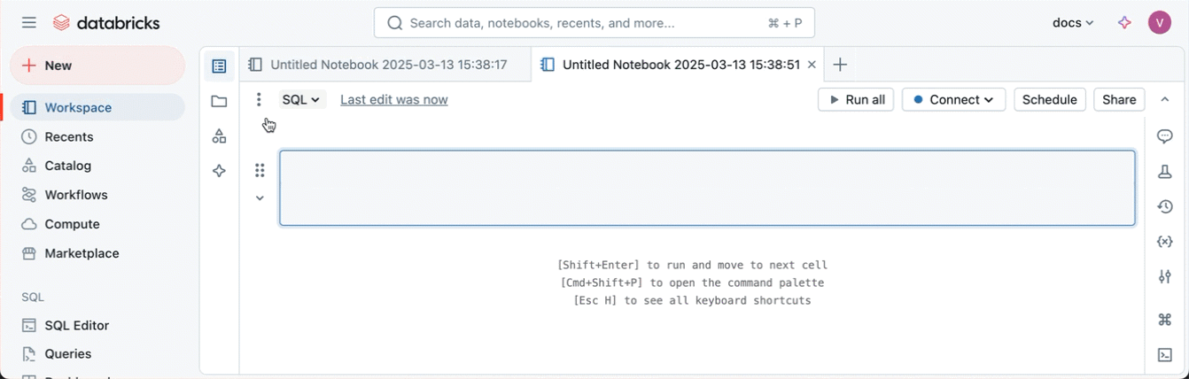
Figure 3. A new notebook with its first code cell and top toolbar.
Source: Microsoft Learn - Azure Databricks documentation
WHAT TO SAY: The notebook is the instruction document. It does not supply processing power. The compute selector connects the notebook to the resource that will execute the instructions.

Step 3 - Understand the notebook toolbar
Figure 4. Current notebook toolbar: language, Run all, compute selector, Schedule and Share.
Source: Microsoft Learn - Azure Databricks documentation
Control | Purpose | Classroom rule
Python selector | Sets the default language for new code cells. | Use Python; use %sql for SQL cells.
Run all | Runs cells from top to bottom. | First run cells individually so errors are easier to explain.
Connect / compute | Attaches the notebook to serverless or classic compute. | Select only trainer-approved compute.
Schedule | Creates an automated notebook job. | Do not schedule during this introductory lab.
Share | Controls notebook permissions. | Use only the approved class group.

Step 4 - Attach approved compute
- Open the compute selector in the notebook toolbar.
- Select Serverless when it is available and approved.
- Otherwise select the trainer-created shared compute resource.
- Wait for the status to become connected before running Spark code.
CURRENT BEHAVIOR: In eligible Unity Catalog workspaces, a new notebook can default to serverless when code is first executed and no other compute was selected. Availability still depends on workspace and region support.
CLASSIC COMPUTE FALLBACK: If classic compute is used, learners need CAN ATTACH TO. The trainer should enforce a small policy and auto-termination; students should not create unrestricted compute.

Part F - Execute notebook cells and save a Delta table

Step 5 - Create code and text cells
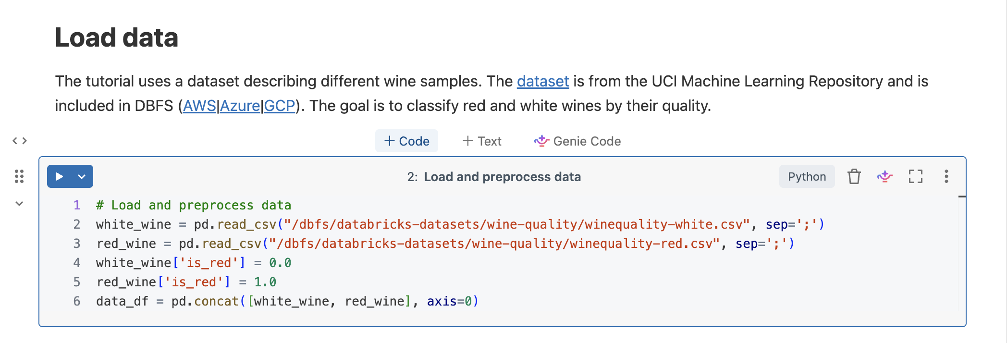
Figure 5. Hover between cells to add + Code, + Text or Genie Code.
Source: Microsoft Learn - Azure Databricks documentation
- Choose + Code for executable Python or SQL.
- Choose + Text for formatted notebook documentation.
- Use Genie Code only as an optional demonstration; learners must still understand and validate generated code.

Step 6 - Run the first Python cell
PYTHON
print("Hello Azure Databricks!")
print("Spark version:", spark.version)
Expected result: the greeting is printed, followed by the Spark version available to the connected compute.

Step 7 - Use the run menu
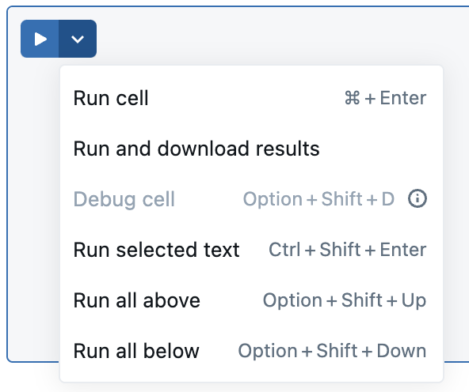
Figure 6. Cell run menu for one cell, selected text, cells above or cells below.
Source: Microsoft Learn - Azure Databricks documentation
WINDOWS SHORTCUT: Use Ctrl+Enter to run selected cells. Shift+Enter commonly runs the cell and moves to the next cell. Demonstrate the on-screen Run button first because shortcuts can differ by operating system and browser.

Step 8 - Verify identity and namespace
SQL
%sql
SELECT
current_user() AS logged_in_user,
current_catalog() AS current_catalog,
current_schema() AS current_schema;
The learner must record the returned identity, catalog and schema. This is the first diagnostic query whenever permissions or object resolution behave unexpectedly.

Step 9 - Select the learner schema and create a volume
PYTHON
student_id = "01" # replace with the assigned number
catalog = "training_lab"
schema = f"student_{student_id}"
spark.sql(f"USE CATALOG {catalog}")
spark.sql(f"USE SCHEMA {schema}")
spark.sql("CREATE VOLUME IF NOT EXISTS landing")
display(spark.sql("SELECT current_catalog(), current_schema(), current_user()"))
EXPECTED RESULT: The notebook uses training_lab.student_XX and the landing volume exists. If namespace selection fails, verify the trainer-created schema, USE CATALOG, USE SCHEMA and CREATE VOLUME privileges; do not request administrator access.

Step 10 - Create and display a DataFrame
PYTHON
students = [
(1, "Asha", 85),
(2, "Ravi", 72),
(3, "Meena", 91),
(4, "Imran", 68)
]
students_df = spark.createDataFrame(
students,
["student_id", "student_name", "marks"]
)
display(students_df)
student_id | student_name | marks
1 | Asha | 85
2 | Ravi | 72
3 | Meena | 91
4 | Imran | 68

Step 11 - Filter the DataFrame
PYTHON
passed_df = students_df.filter(students_df.marks >= 75)
display(passed_df)
Expected result: Asha and Meena are displayed. Explain that filter defines a transformation; displaying the result causes execution.

Step 12 - Query the same data with SQL
PYTHON
students_df.createOrReplaceTempView("students")
SQL
%sql
SELECT student_name, marks
FROM students
WHERE marks >= 75
ORDER BY marks DESC;
student_name | marks
Meena | 91
Asha | 85

LEARNING POINT: Python created the DataFrame and SQL queried it. The temporary view belongs to the current Spark session; reconnecting compute can require rerunning the cell that creates the view.

Step 13 - Build the order result
PYTHON
from pyspark.sql import functions as F
orders = [
(1001, "Asha", "Laptop", 2, 50000.0),
(1002, "Ravi", "Mouse", 5, 800.0),
(1003, "Meena", "Keyboard", 3, 1500.0)
]
orders_df = spark.createDataFrame(
orders,
["order_id", "customer", "product", "quantity", "unit_price"]
)
result_df = orders_df.withColumn(
"total_amount",
F.col("quantity") * F.col("unit_price")
)
display(result_df)
Expected result: three orders are displayed with total_amount values 100000, 4000 and 4500.

Step 14 - Save the result as a governed Delta table
PYTHON
table_name = f"{catalog}.{schema}.orders"
result_df.write \
.format("delta") \
.mode("overwrite") \
.saveAsTable(table_name)
print("Saved:", table_name)
For Student 01, table_name resolves to training_lab.student_01.orders. The three-level identifier means catalog.schema.table. Delta is the storage and transaction format; Unity Catalog governs discovery, ownership and permissions.
OVERWRITE WARNING: mode("overwrite") replaces the existing table data. Use it for this repeatable lab only. Production ingestion commonly uses append, MERGE or a controlled full-refresh design.

Verify the Delta table
SQL
%sql
SELECT *
FROM training_lab.student_01.orders
ORDER BY order_id;
DESCRIBE HISTORY training_lab.student_01.orders;
Learners other than Student 01 must replace student_01 with their assigned schema. The query should return three rows, and DESCRIBE HISTORY should show a table creation or overwrite operation.

Step 15 - Add learner documentation
TEXT / MARKDOWN
# Student Marks Analysis
This notebook demonstrates:
1. Python execution
2. Spark DataFrame creation
3. DataFrame filtering
4. SQL querying
5. Identity and namespace validation
Use + Text for the current notebook text-cell experience. In a code cell, %md can also be used when supported by the selected notebook language behavior.

Part G - Inspect performance and preserve evidence

Step 16 - View query performance
After a supported SQL or Python statement completes on serverless compute, expand the performance link to inspect rows read, bytes read, duration and the query profile entry.
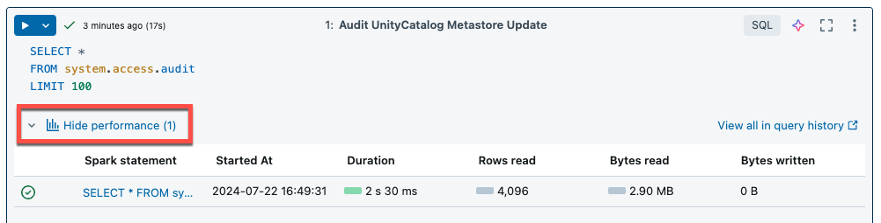
Figure 7. Serverless notebook performance insights after a statement finishes.
Source: Microsoft Learn - Azure Databricks documentation
- Duration shows how long the statement took.
- Rows and bytes read help identify unnecessary scans.
- Bytes written indicate whether the statement produced persisted output.
- Query profile visualizes operators and data movement for supported statements.

Step 17 - Record completion evidence
- Rename and save the notebook under the learner home workspace folder.
- Keep the successful identity query output visible.
- Keep the DataFrame and SQL results visible.
- Copy the notebook URL or take only the trainer-approved screenshot.
- Submit the notebook path and validation evidence using the classroom process.
PRIVACY: Before sharing a screenshot, confirm that it does not expose access tokens, connection strings, secrets, unrelated user identities or sensitive datasets.

Part H - Troubleshooting guide
Symptom | Likely cause | Trainer response
No compute attached | No resource selected or classic compute terminated. | Select serverless/approved compute and wait for connection.
Compute not listed | Missing ACL, policy restriction or serverless unavailable. | Check CAN ATTACH TO, policy, Unity Catalog and region support.
Notebook opens read-only | Learner lacks edit permission on that notebook/folder. | Clone to the learner folder or correct the narrow folder permission.
Schema creation denied | Missing CREATE SCHEMA or catalog use permission. | Use the pre-created learner schema; verify USE CATALOG and ownership.
students not found | Temporary view cell was not executed in the current session. | Run the Python cell that creates the temporary view.
Name resolved in wrong schema | Current catalog/schema differs from expectation. | Run current_catalog/current_schema and explicitly USE the learner namespace.
Cell keeps running | Large operation, blocked dependency or compute issue. | Inspect status; interrupt safely; review query performance and logs.
Run all stops after an error | An earlier cell failed or cells depend on missing state. | Run top-to-bottom and correct the first failure before continuing.

Trainer recovery order
- Confirm the learner identity and correct workspace.
- Confirm notebook edit permission.
- Confirm approved compute selection and connection.
- Run current_user(), current_catalog() and current_schema().
- Confirm catalog/schema permissions.
- Rerun prerequisite cells in order.
- Use the synthetic DataFrame fallback if external data is unavailable.

Do not use these shortcuts
- Do not make every learner a workspace administrator.
- Do not grant access to the entire metastore or storage account to solve one schema issue.
- Do not paste secrets into notebook cells or screenshots.
- Do not let every learner create unrestricted classic compute.
- Do not teach DBFS mounts as the default Azure storage integration pattern.

End-of-lab cleanup
- Learners confirm that the orders table and notebook evidence were submitted before cleanup.
- If the lab must be reset, each learner drops only the table in the assigned schema.
- The trainer terminates or deletes shared classic compute after the final session. Serverless compute does not require cluster termination.
- At the end of the full program, remove temporary workspace assignments according to the client access process.
- Delete rg-dbx-training only when it is dedicated to this lab, the subscription owner approves, and no retained artifacts are required.
OPTIONAL RESET FOR STUDENT 01
%sql
DROP TABLE IF EXISTS training_lab.student_01.orders;
DESTRUCTIVE ACTION: Dropping a table or deleting the Azure resource group removes lab assets. Confirm the exact learner schema and obtain the agreed cleanup approval before performing either action.

Part I - Trainer delivery notes and assessment

Five-minute explanation script
“Azure deploys the Databricks workspace, Microsoft Entra ID supplies our identities, compute executes notebook instructions, and Unity Catalog governs the data. We will create Python DataFrames, query data with SQL and persist the final order result as a Delta table named with catalog, schema and table.”

Learner-check questions
- What is the difference between the Azure portal and the Databricks workspace?
- Why does a notebook require compute?
- When should serverless compute be preferred?
- What does current_user() help diagnose?
- Why can a temporary view disappear after a compute reconnection?
- What is the difference between notebook compute and a SQL warehouse?
- What do catalog, schema and table represent in training_lab.student_01.orders?
- How is a temporary DataFrame different from a governed Delta table?

Completion rubric
Criterion | Points | Pass evidence
Workspace and notebook | 15 | Correctly named notebook in the learner folder.
Compute | 10 | Connected only to approved compute.
Identity and namespace | 15 | Correct user, catalog and schema shown.
Python/DataFrame | 15 | DataFrame and filtered result execute successfully.
SQL | 15 | Temporary view query returns Meena and Asha.
Delta table | 20 | Assigned orders table contains three rows and Delta history.
Documentation and safety | 10 | Text cell added; no secrets or unrelated identities exposed.

Suggested timing
Time | Activity
0-10 min | Concept recap and workspace orientation
10-25 min | Notebook creation and compute connection
25-60 min | Python, identity and DataFrame exercises
60-80 min | Temporary view and SQL
80-100 min | Order result and governed Delta table
100-110 min | Performance view and troubleshooting
110-120 min | Validation, learner check and evidence submission

Official sources and version note
The screenshots and interaction steps were checked against the following Microsoft Learn pages on 10 September 2026. Azure Databricks interfaces can vary by rollout, workspace type, region, configuration and entitlement; use the stated outcome and control purpose as the stable teaching anchor.
- Create an Azure Databricks workspace
- Deploy a workspace using the Azure portal
- Manage Azure Databricks users
- Compute configuration reference
- Create Unity Catalog catalogs
- Create Unity Catalog schemas
- Manage Databricks notebooks
- Basic editing in Databricks notebooks
- Serverless compute for notebooks
- Manage classic compute
- Per-workspace URLs and Launch Workspace

Final trainer checklist
- The workspace type, region, subscription owner and cleanup date are approved.
- The 14 learner identities are assigned without Databricks admin access.
- The screenshot sequence matches the learner-facing steps.
- All learner identities and schemas are assigned before class.
- Serverless or approved classic compute was tested from a learner account.
- The fallback synthetic lab runs without external data.
- Each learner can create and query orders only in the assigned schema.
- Auto-stop, cost ownership and cleanup responsibilities are confirmed.

